**LAخSLY**

**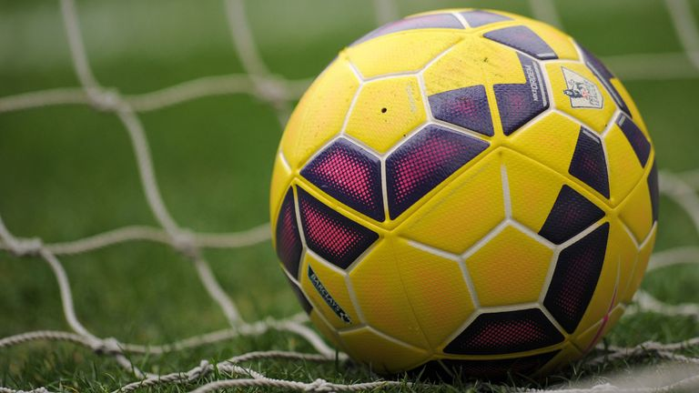**

**Graduation Project Progress Report**

**Team Members:**

Ahmed Maher

Ahmed Salama

Moamen Hassan

Mohamed Talaat

**Supervised by:**

Dr.Magda Fayek

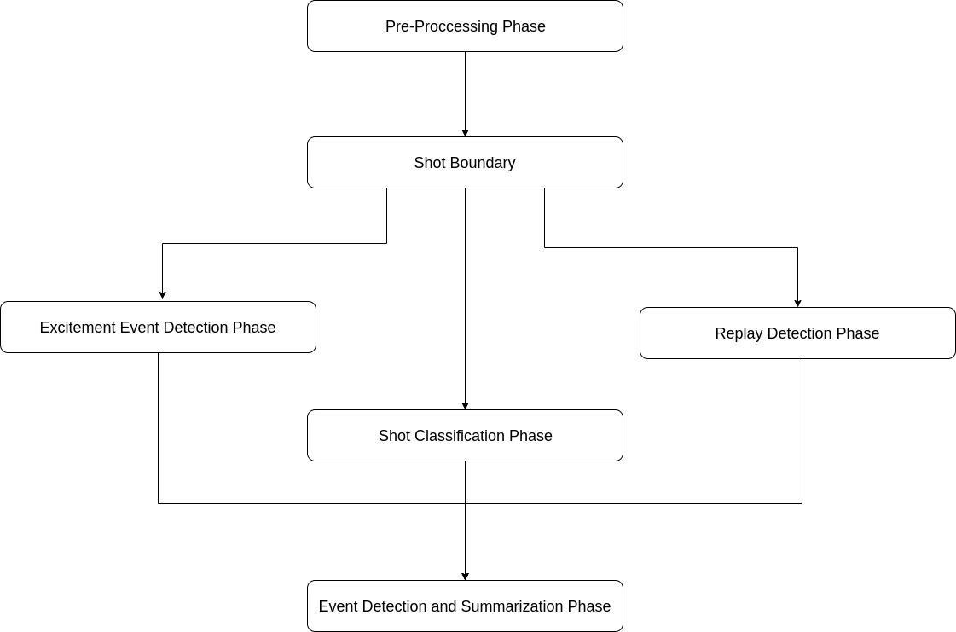

Figure 1 the proposed system

**In the following sections we discuss what we reached in the Pre-processing phase and shot boundary phase**

**1.Pre-processing phase:**

The goal of this phase is to segment the whole video stream into small video shots by detecting the dominant color and the histogram of each frame then the shot boundary detection algorithm is applied.

**1.1 Dominant color detection:**

The dominant color is the color that fills most of a given area , and it’s different among various play fields, with the help of the following figure we can clearly see that the dominant color differs from one sport to another, but in the proposed project we are concerned only with soccer game which has a green color for the playing field.

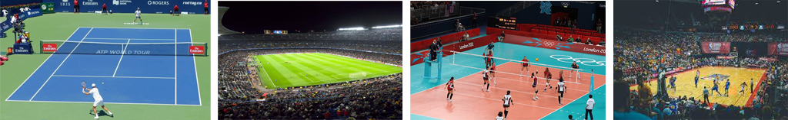

Figure 2 dominant color in different sports

The playing field usually has distinct tone of green that may vary from one stadium to another, even in the same stadium this green color may change due to weather and lighting conditions, with the help of the following figure we can see these changes.

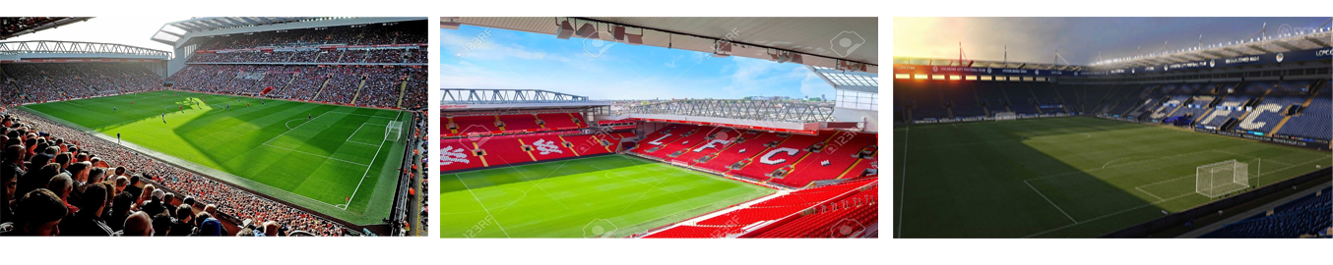

Figure 3 tones of green

Distinguishing field color from others is not as easy as one may think because RGB values may change under different lighting and weather conditions as we showed in the previous figure so we have developed an algorithm based on HIS color space which is more robust to change in lighting conditions, in the following we show the steps of the algorithm.

**Algorithm for Grass dominant ratio extraction:**

***1: read the input video.***

***2: for each frame do.***

***2.1: convert frame form RGB to HIS.***

***3: define the color range that covers the different variations of the play field’s green color.***

***4: for each pixel do.***

***4.1: if the HIS components range as follows***

***4.1.1: 0.4 > Hue > 0.15***

***4.1.2: 0.6 > Intensity > 0.2***

***4.1.3: 1 > Saturation > 0.1***

***4.2: set the pixel to ‘White’***

***4.3: otherwise, set the pixel to ‘Black’***

***4.4: end if***

***5: end for***

***6: end for***

**Note**: the above numbers have been developed based on try and error on different soccer matches from the premier league (English league) with different weather and lighting conditions.

1.2 Results of Grass Dominant color Ratio Algorithm

**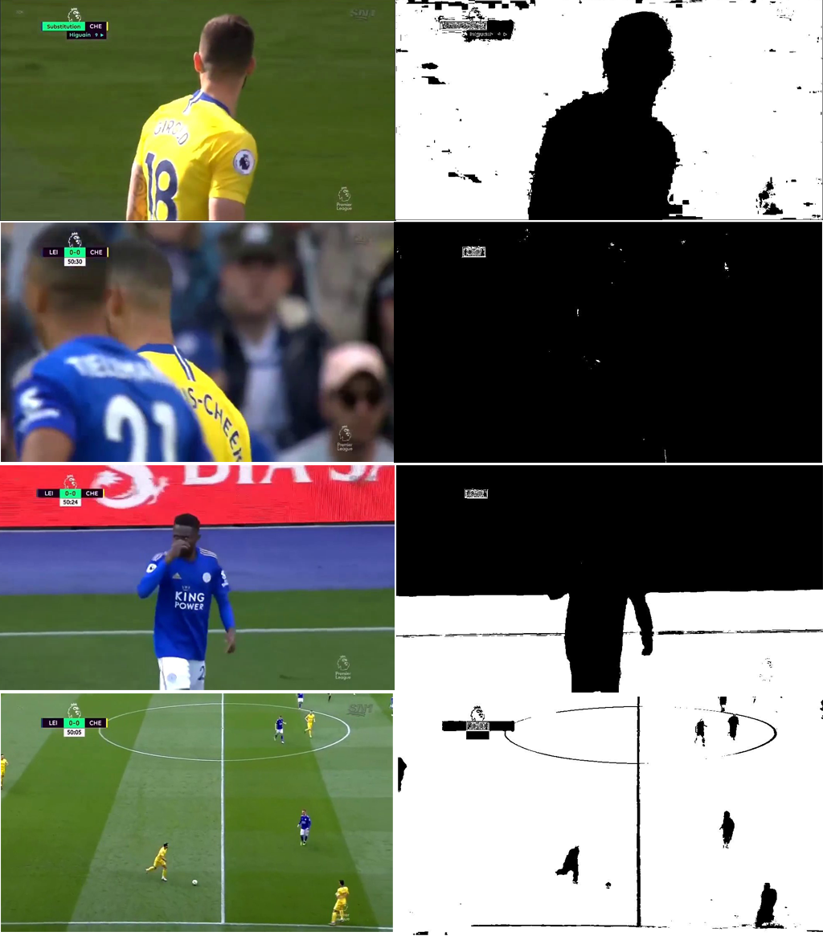**

Figure results of dominant color

2. shot-boundary detection processThe process of detecting the actual boundary of shots depending on finding the difference between frames by computing frame-to-frame differences in some features and look for a large difference value that should indicate the start of a new shot.  
The correlation between frames in the same shot is a very important indicator to detect the similarity between them and when there is noticeable change we can conclude the starting of new shot as we mentioned.

You must be aware that there are different transitions that may occur during the match, so the next section illustrates this point in more details.

2.1 Types of shot transitionsthere is two types of transition depending on the camera movement and transition; illustrated in Figures 1,2

1) instant (cut) transition

2) gradual transition. When there is a special editing effects during the match  
to illustrate the transition, we said; gradual transition while the instant transition hasn’t any effects and it is more accurate than the gradual one

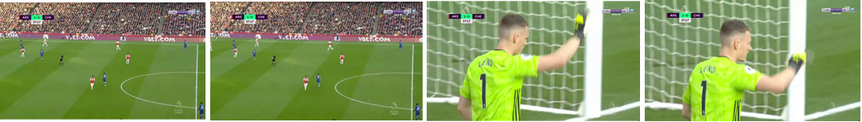

Figure 5 example of an instant cut

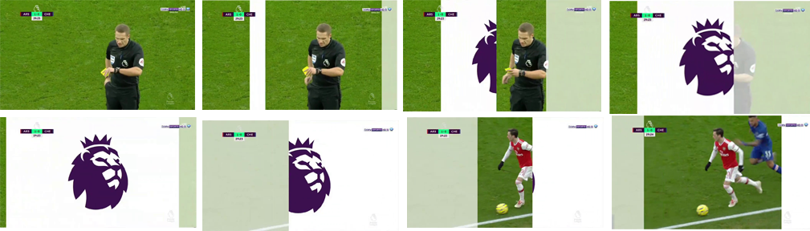

Figure 6 example of a gradual cut

2.3 Shot-boundary detection algorithm

After discussing the previous basic concepts that are very important to deal with in  
this section, we present the hierarchal steps of the shot-boundary detection  
algorithms simply by following the flowchart in Figure (4.4).  
We use two main features for shot-boundary detection:  
• The intersection of color histogram of two consecutive frames.

**Intersection of two histograms h1, h2**

d(H_1,H_2) =  \sum _I  \min (H_1(I), H_2(I))

• The correlation of color histogram of two consecutive frames.

**Correlation of tow histograms h1, h2**

d(H_1,H_2) =  \frac{\sum_I (H_1(I) - \bar{H_1}) (H_2(I) - \bar{H_2})}{\sqrt{\sum_I(H_1(I) - \bar{H_1})^2 \sum_I(H_2(I) - \bar{H_2})^2}}

where

\bar{H_k} =  \frac{1}{N} \sum _J H_k(J)

Since color histograms are robust to moderate object and camera motions, we  
represent a frame by its color histogram, which is defined in the RGB space.  
The similarity between the two histograms is measured by histogram intersection and histogram correlation.

The proposed shot-boundary detection algorithm is able to detect both instant and  
gradual transitions with a high detection and low false alarm rates.  
The detection of gradual transitions in sports video is particularly difficult because of the  
high color correlation between two shots so Instead of computing the difference vector for every consecutive frame pair, the comparisons are performed between frame i and frame i + placement K: Unless there is a significant difference, the comparisons are only defined for frames that are placement K apart. This is done to transform the gradual cut to an instant cut.

We have observed that the placement K has an upper bound of k = 5.

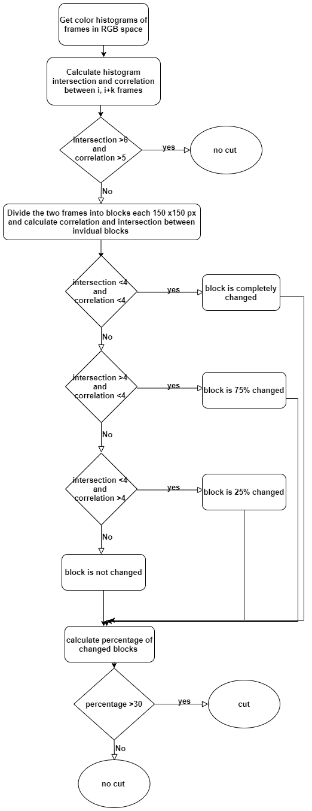

Figure 7 shot boundary detection algorithm

2.4 Shot-boundary detection algorithm Results

We tested the proposed algorithms on 6 short videos of different durations extracted from different football matches

|  |  |  |  |
| --- | --- | --- | --- |
| Test | Duration in minutes | Number of cuts | efficiency |
| Test1.mp4 | 5 | 15 | 100% |
| Test2.mp4 | 2:22 | 21 | 80.9% |
| Test3.mp4 | 1:36 | 19 | 89.4% |
| Test4.mp4 | 3:12 | 38 | 84.2% |
| Test5.mp4 | 3:18 | 38 | 92% |
| Test6.mp4 | 4:41 | 37 | 86% |